|  |
| --- |
| College LaSalle |
| Project - Internet Programming User Manual |
|  |
| Presented to: Mihai Maftei |

|  |
| --- |
| Author: Amin Saedi  11/26/2022 |

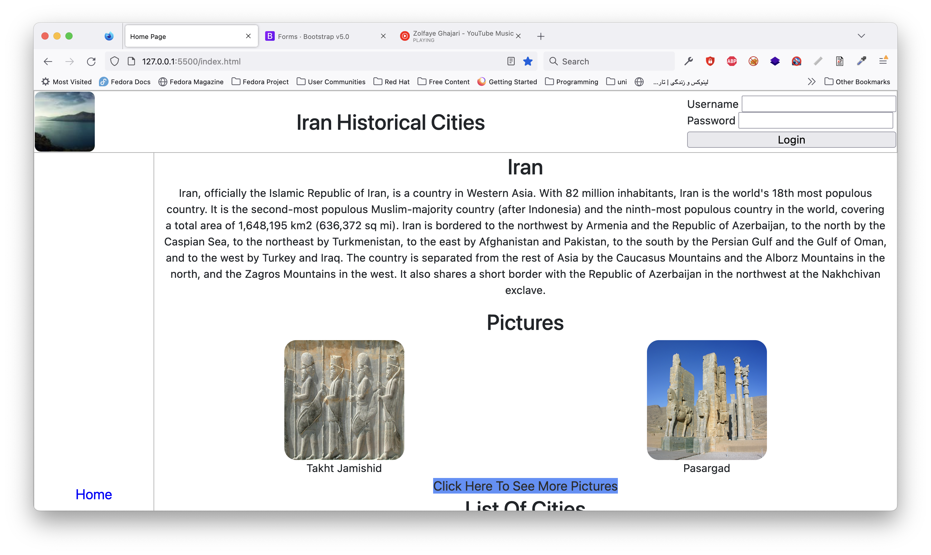

This website has four web pages which are accessible for all users and two pages which can be access only by authenticated users (see login section).

The main topic is about to describe some cities of Iran and their attractions. The website is in English language.

On the home page you can see the list of cities with their estimated population and a shot description about history of Iran.

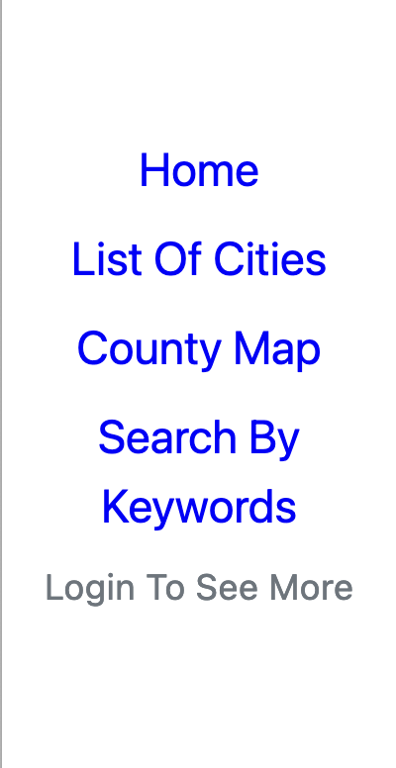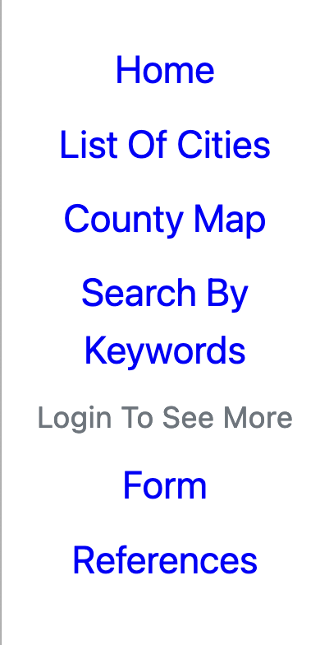

By default, the left side menu contains a list of pages which are accessible for all users and ig you login you can see the list of pages which are accessible only for authenticated users. (Form page and references page)

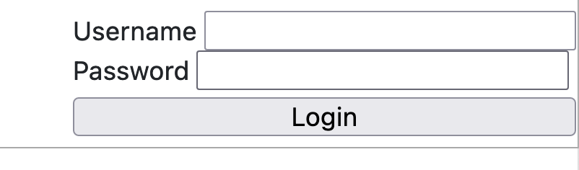

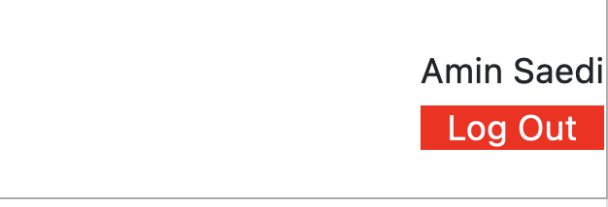

Login section is always on the top right of the page and you can login by using "amin@proj.ca" as username and "123" as password.

After you login you can see the red logout button on the top right of the page. and you can logout by clicking on it.

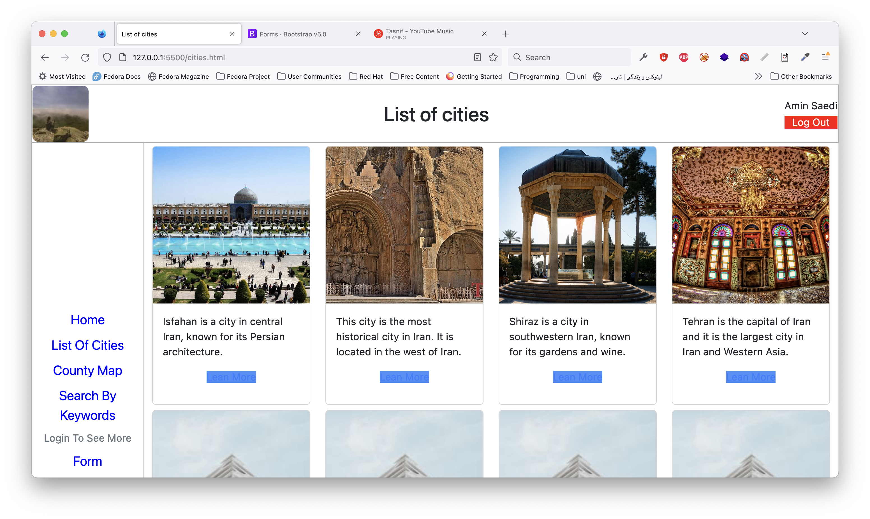

In this page you can see list of few cities of Iran with an image and a short description about them.

I also put some cards with fake data to fill the page.

If you click on the "Learn more" button you will be navigated to the wiki page of that city.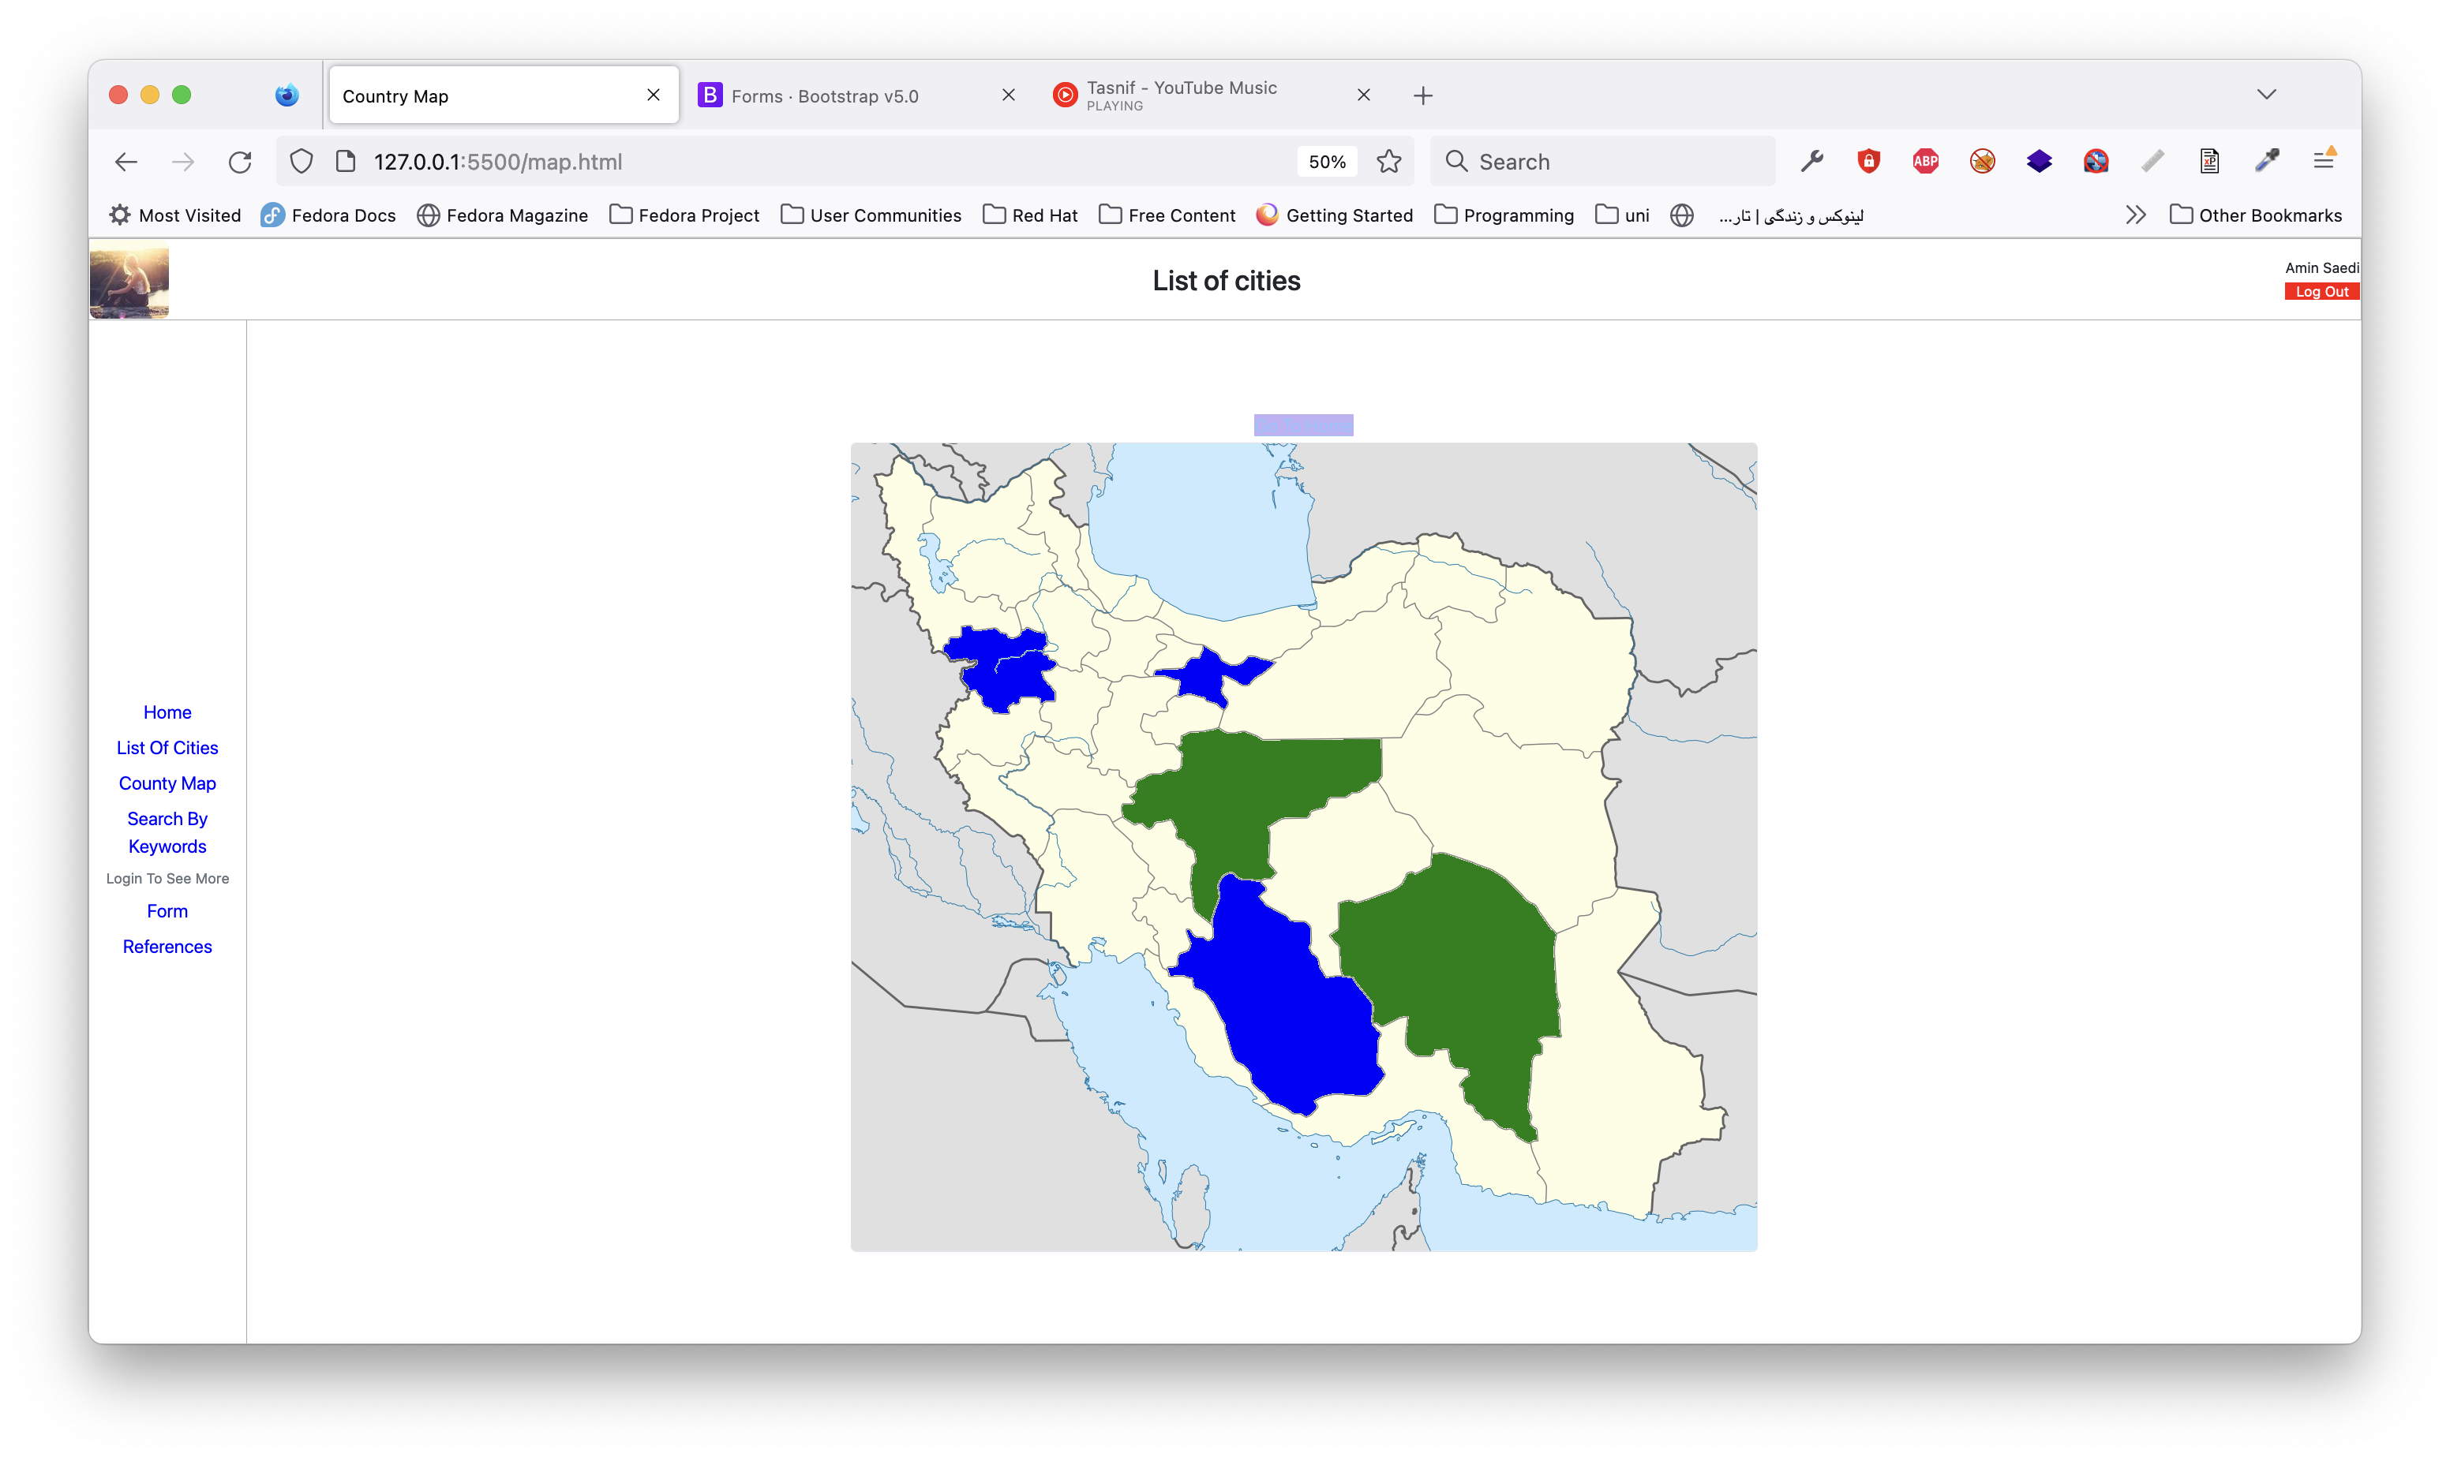

Using the map screen you can find all the listed cities on the map and you can see the details of each city by clicking on colored markers.

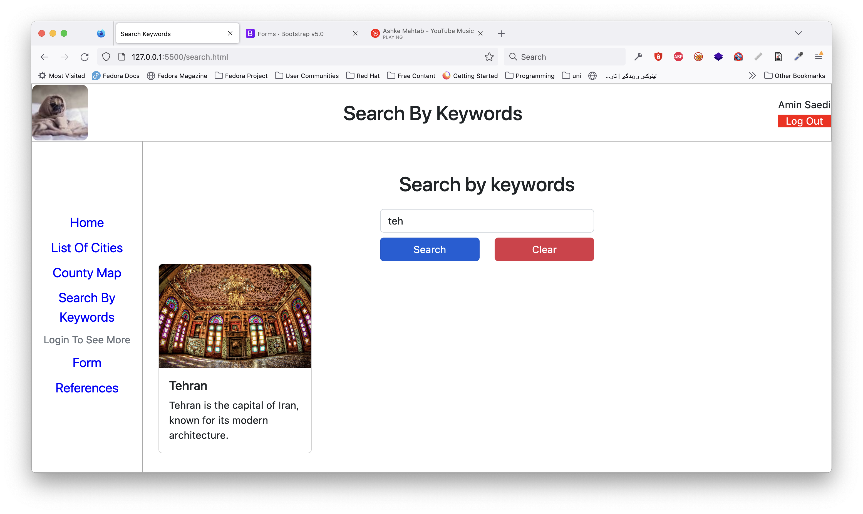

If you want to search for a city you can use this page and it will try to find the city you are looking for.

Clear button will clear the current search result and lets you to search for another city

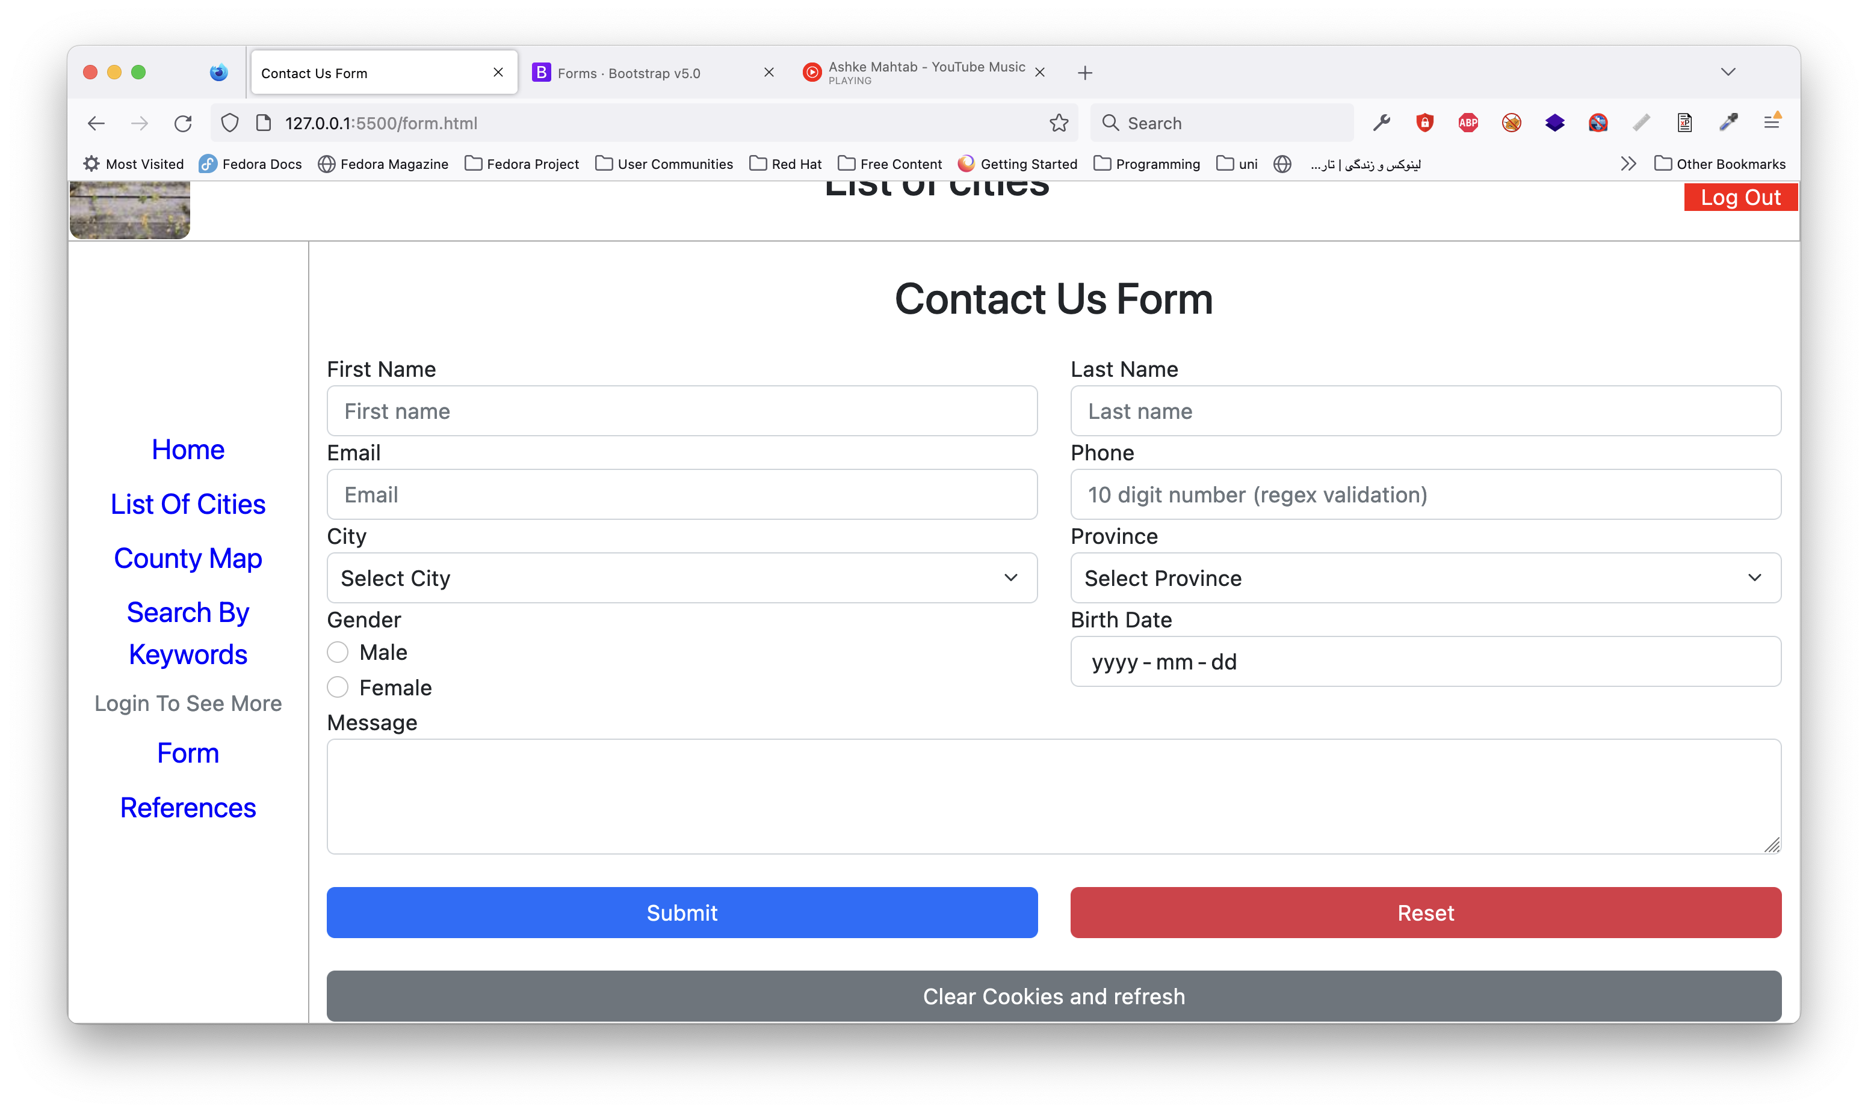

Contact Us page is used to send a message to the website owner and ask to add a new city to the website.

This page is accessible only for authenticated users. and also it keeps your data after you click on the "Submit" button, so next time you can edit your message and send it again.